Create and Configure Virtual Machines on Azure

**Create a Windows Virtual Machine in the Azure Portal**

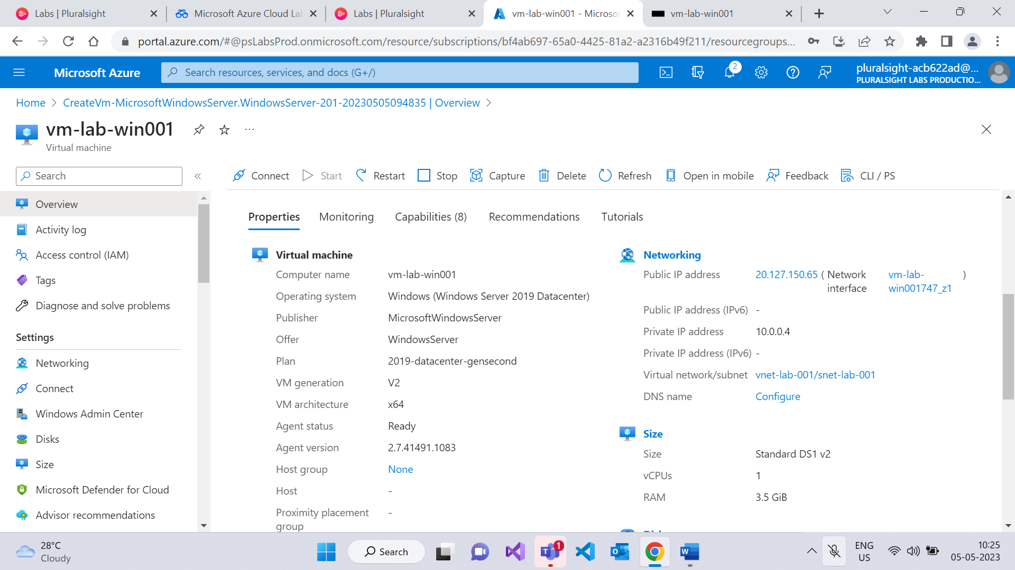

**Configure Virtual Machine Access with Azure Bastion**

Azure Bastion can be deployed into your virtual networks for a secure connection to virtual machines. Azure Bastion is launched from the Azure Portal giving administrators access to their virtual machines through a web browser. No Remote Desktop client or SSH client needs to be installed locally.

